**Whitepaper**

**Developing a Strategic Advocacy Framework to Improve Local Migraine Care and Support**

**Output from the policy roundtable on recommendations on driving change on migraine at local level held on December 6th during the European Headache Congress**

**Panelists:**  
Ms. Dehenna Davison, Ms. Guusje ter Horst, Dr. Reto Agosti, Ms. Jannet Vaessen, Prof. Peter Goadsby, Dr. Messoud Ashina, Ms. Elena Ruiz de la Torre  
**Moderator:** Dr. Olga Fidalgo

**Introduction**

**Migraine is a complex and often debilitating neurological disorder** affecting a significant portion of the global population. **Despite being the second leading cause of years lived with disability** (YLD) globally, as reported in the 2019 Global Burden of Disease Study, **migraine remains underrecognized and undertreated**. This lack of attention results in delayed diagnoses, inadequate treatment, and substantial socioeconomic costs.

This **whitepaper presents the key findings and recommendations from the policy roundtable held at the European Headache Congress**, where leading experts discussed actionable steps to address the gaps in migraine care at the local level.

The discussions focused on **three key areas:**

1. Timely Screening and Diagnosis
2. Commitment on recognizing migraine as a neurological disease & Transforming Patient Pathway
3. Expanding Coverage and Early Access to Therapeutic Innovation

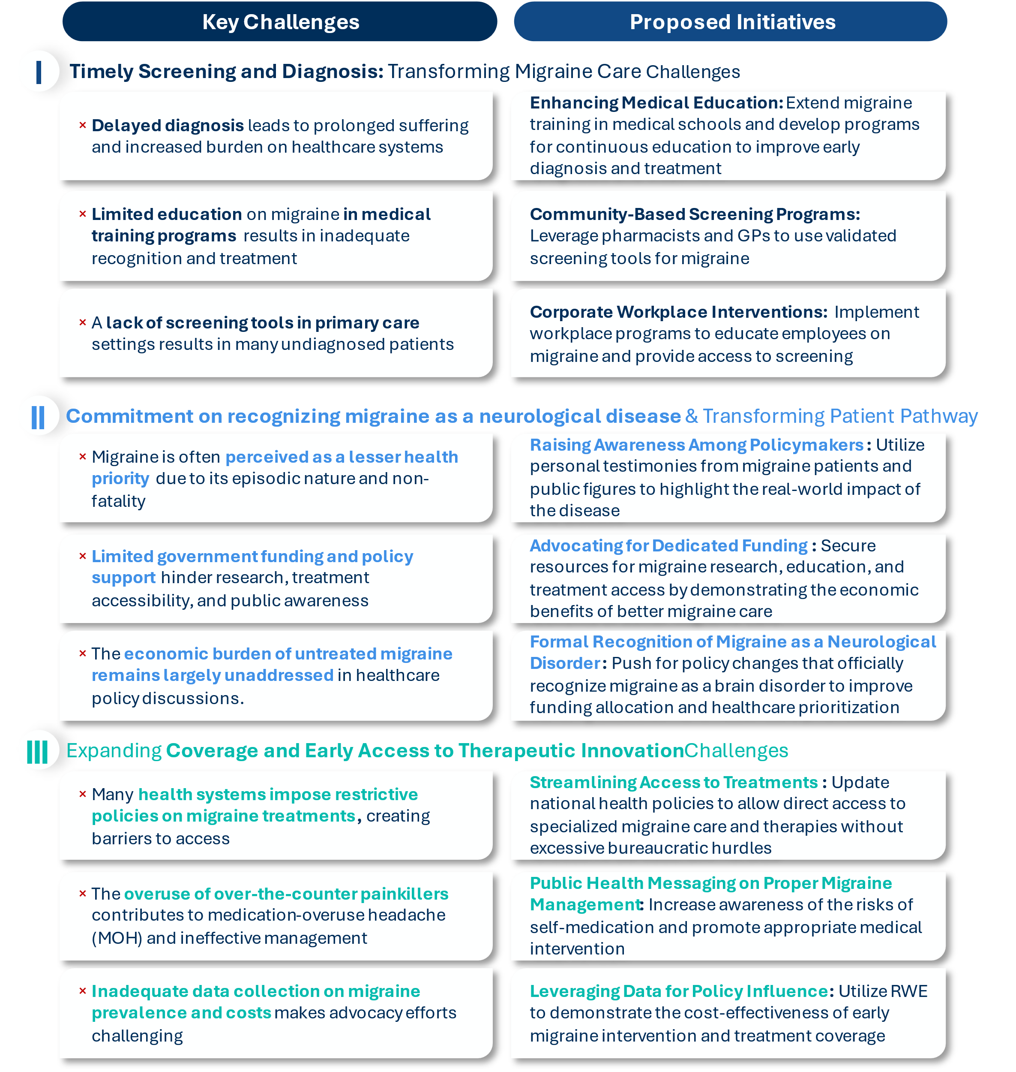**Key challenges per discussion area and recommended initiatives** from the policy roundtable held at the European Headache Congress

**Conclusion**

**Addressing the global burden of migraine requires a multi-stakeholder approach**, integrating healthcare providers, policymakers, patient advocacy groups, and corporate leaders. By **prioritizing early diagnosis, securing political commitment, and ensuring equitable access to treatment, we can significantly improve migraine care** and reduce its impact on millions of individuals worldwide.

**Through sustained advocacy and collaboration, we can move toward a future where migraine is recognized, adequately resourced, and effectively managed** within healthcare systems and society at large.

**Policy roundtable: Recommendations on driving change on migraine at local level | December 6th – Blue Room at European Headache Congress**

**Panelists:**

Dr. Reto Agosti

Ms. Guusje ter Horst

Ms. Dehenna Davison

Ms. Jannet Vaessen

Ms. Elena Ruiz de la Torre

Dr. Messoud Ashina

Prof. Peter Goadsby

**Moderator:**

Dr. Olga Fidalgo

**Migraine Context Setting**

Migraine is a complex and often debilitating neurological disorder affecting a significant portion of the global population, yet it remains underrecognized and undertreated by both society and healthcare systems. Despite being the second leading cause of years lived with disability (YLD) globally, as reported in the 2019 Global Burden of Disease Study, migraine is often dismissed as a minor ailment, leading to insufficient attention and resources being dedicated to its management (Vos et al., 2020).

For many patients, obtaining an accurate diagnosis is a prolonged and challenging journey. According to the survey done by EMHA regarding access to care, it can take several years and visits to multiple healthcare providers, including general practitioners, before patients are referred to a neurologist who typically confirms the diagnosis (Lipton et al., 2007). This diagnostic delay can exacerbate the patient’s condition, reduce quality of life, and increase the socioeconomic burden associated with untreated or poorly managed migraine.

Epidemiological data highlights the pervasive nature of migraine. Globally, migraine affects approximately 1 in 7 people, with a prevalence of 14.7% of the population (Stovner et al., 2018). It is three times more common in women than in men, reflecting hormonal influences in its pathophysiology. In Europe, the prevalence among adults is reported to be as high as 15%, with the highest burden observed in individuals aged 25–55, often impacting their most productive years (Linde et al., 2012).

Despite these staggering figures, migraines remain disproportionately under resourced compared to other neurological conditions. There is an urgent need for increased awareness, timely diagnosis, and equitable access to effective treatment to address this neglected disease. Bridging these gaps in care is critical to reducing the significant personal and societal burden posed by migraine.

References:

* Vos, T., et al. (2020). Global Burden of Disease Study 2019. The Lancet.
* Lipton, R. B., et al. (2007). Migraine diagnosis & treatment: results from the American Migraine Study II. Headache.
* Stovner, L. J., et al. (2018). Global prevalence of headache disorders: a systematic review. Cephalalgia.
* Linde, M., et al. (2012). The prevalence of migraine and the impact on quality of life in Europe. Neurology.

**PERSPECTIVES ON** **THE MOST IMMEDIATE AND PRESSING NEEDS IN THE MIGRAINE SPACE AND INITIATIVES TO ADDRESS THEM**

The roundtable discussion highlighted key priorities for advancing migraine care, focusing on the most pressing needs and high-impact opportunities. The following priorities emerged as critical areas for action:



**A.**

**Improving Timely Screening and Diagnosis**

**B.**.

**Commitment on recognizing migraine as a neurological disease**

**& Transforming Patient Pathway**



**C..**

**Expanding Coverage and Early Access to Therapeutic Innovation Innovation**

By focusing on these priorities and implementing initiatives that address these needs—such as enhancing medical education, increasing community care involvement, and introducing workplace interventions—while continuing to raise public awareness, advocate politically, and leverage data that highlights the economic benefits of better care, the involved stakeholders will have the opportunity to significantly improve migraine treatment and management, ultimately positively impacting the lives of millions. Emphasizing the collaboration between patient advocacy groups, healthcare professionals—including general practitioners, pharmacists, and neurologists—, policymakers and corporate leaders can create a holistic framework for tackling migraine care at multiple levels. Through coordinated efforts, we can ensure that migraine is recognized as a neurological disorder, not just a common headache, and that the necessary resources are allocated for effective management.

**A. Improving Timely Screening and Diagnosis: Transforming Migraine Care**

**Improving screening and early diagnosis is widely regarded as a transformative approach to migraine management.**

While innovative therapeutic options are now available, their impact is limited if a significant proportion of people with migraine remain undiagnosed and unable to benefit from these advancements. In their view, governments must prioritize improving migraine diagnosis, as accurate and timely identification of the condition is essential for maximizing the potential of even the most groundbreaking treatments.

Integrating migraine diagnosis and treatment into community-based care is a key step in closing this gap. Strengthening the role of general practitioners (GPs) is particularly crucial, as they are often the first point of contact for patients experiencing migraine symptoms. In many countries, the most significant barrier is the lack of diagnosis and referral from GPs to specialists, leaving many patients without access to appropriate care. Enhancing GP education and increasing awareness of referral pathways could help bridge this divide, ensuring that more patients receive timely and effective treatment.

Building on this, the alarming gap in headache education must be addressed. In many countries, medical training dedicates minimal time to this critical area—only 4 hours in Holland and just 1 hour in Switzerland. Expanding education on migraine diagnosis and management is vital to equipping healthcare professionals with the necessary knowledge to improve early detection and patient outcomes. By strengthening training efforts at both the generalist and specialist levels, healthcare systems can take a significant step toward reducing delays in diagnosis and optimizing treatment access for migraine patients.

**Initiatives to be considered to improve screening and diagnosis are as follows:**

**1. Enhancing Education During Medical Training**

The time currently dedicated to learning about migraines during medical studies is clearly insufficient—between 2 and 4 hours—and likely reflects the lack of importance attributed to this condition. Given the high prevalence of migraines and their significant impact on patients' daily lives, enhancing education on this topic within medical school curricula and professional training programs is crucial to equipping healthcare professionals with the knowledge needed for effective diagnosis and management.

Expanding education beyond specialist training is equally important. General practitioners (GPs) and community pharmacists, particularly in countries like the UK, often serve as the first point of contact for individuals experiencing migraine symptoms. Strengthening their education on migraine diagnosis and treatment, alongside promoting the use of validated screening tools in primary care and pharmacy settings, can facilitate earlier identification and appropriate management of patients



**2. Implementing Community-Based Initiatives**

**Public Health Screening:**

*Including migraine in health questionnaires used in public healthcare programs can help identify undiagnosed cases.* For instance, in Denmark, school nurses already conduct health questionnaires as part of public health initiatives. However, only a small percentage of these nurses are trained to recognize migraine as a potential issue. Closing this gap and identifying young sufferers through such programs could prevent the loss of an entire generation of undiagnosed individuals. Starting early with educational initiatives, such as school-based health assessments or public awareness campaigns, can also help shift public perception and reduce the stigma around migraine.

**Pharmacist Involvement:**

*In countries like the UK, community pharmacists may play a significant role in the early identification and management of migraine.* Utilizing simple tools like the three-item screener questionnaire, which is 92% predictive, pharmacists can support screening and diagnosis at the community level. With many medications accessible directly at the pharmacy, pharmacists can facilitate early intervention, which has the potential to significantly reduce healthcare costs while improving patient outcomes.

In countries where pharmacists are not authorized to diagnose or recommend prescription treatments, they can still play an essential role in identifying potential migraine sufferers and referring them to general practitioners or specialists for accurate diagnosis and proper treatment.

**Corporate Involvement and Workplace Interventions:**

*A critical area for migraine management is in the workplace.* Considering the high prevalence of migraine, it is evident that individuals affected by the condition can be found in virtually every organization. Employers who invest in migraine-friendly workplace policies may see substantial returns, including fewer missed workdays, enhanced employee well-being, and reduced healthcare-related expenses. Workplace initiatives to address migraine, such as education and early diagnosis, can reduce absenteeism and improve productivity. Progressing into the introduction of structured migraine management programs in corporations could further reduce the burden on companies and increase employee retention.

In Switzerland, a program initiated 20 years ago has successfully addressed this issue by focusing on the education of occupational health physicians and raising awareness among employees. The program includes brief, impactful talks about migraine, which have proven highly successful.

*Many employees suffer from frequent migraines but fail to seek treatment due to stigma, lack of knowledge or simply not finding the time to seek specialized care.* Those individuals can potentially be identified through routine health checks conducted by employers. These workplace initiatives provide a valuable opportunity to reach undiagnosed individuals, offering early support and facilitating access to appropriate care. Improved migraine management delivers substantial benefits to companies, such as decreasing the occurrence and length of employee medical absences.

*Patient Advocacy Groups (PAGs) can play a pivotal role in promoting awareness about migraine at the corporate level* by advocating for its inclusion in occupational medicine initiatives.

**B. Commitment on recognizing migraine as a neurological disease & Transforming Patient Pathway**

**Migraine, recognized by the World Health Organization (WHO) as one of the top five most debilitating illnesses**, is often misunderstood and overlooked by policymakers. Despite its significant burden on individuals, businesses, and healthcare systems, there remains a critical lack of political commitment to allocate resources and financial support for its effective management.

From a parliamentary perspective, there were highlighted several key challenges contributing to this issue, including the stigma and low visibility of migraine as a public health priority, policymakers’ tendency to focus on high-fatality or costlier diseases as “people don’t die from migraine”, and the consequent insufficient funding for migraine-specific programs and campaigns.

**Initiatives to gain political commitment are:**

**1. Raising awareness about migraine impact, including voice of patients**

**Policymakers frequently underestimate migraine's impact**, perceiving it as less severe than other neurological conditions due to its episodic nature and low fatality rates. Hearing personal stories directly from someone living with migraines—their experiences, the level of impact on their daily routines, and how it influences decisions affecting their personal and professional lives—is an incredibly powerful tool for raising awareness. Such stories resonate deeply and leave a lasting impression on those who hear them.

**Migraine affects one in seven people worldwide**, meaning it impacts individuals in every sector, including parliaments. Parliamentarians who suffer from migraine can help raise awareness about the condition simply by being open to share their personal experiences. For instance, Ms. Davison, during her tenure as an MP, played a key role in highlighting the stigma and low visibility of migraine as a public health priority. She used her platform to advocate for better recognition of the condition as a serious health issue and pushed for more resources and funding to address its impact. Her efforts exemplify how policymakers with personal experience of migraine can influence meaningful change. A stronger political commitment is not just an opportunity but a necessity to address this widespread yet neglected condition. By prioritizing resources and support for migraine management, governments can make a meaningful difference in the lives of millions while strengthening their healthcare systems and economies.

**PAGs and influential individuals having migraine can play an important role in pushing for policy changes and help raise awareness and pushing for legislative action.** Engaging politicians to take a stand on migraine care is essential. Having champions in government—politicians who recognize the importance of addressing migraine as a serious neurological condition—can help secure funding, resources, and policy reforms. Such champions could also help introduce migraine-related questions or resolutions in parliament, stimulating broader debate and action.

**To achieve lasting progress, neurologists, patient advocates, and other stakeholders must collaborate to raise awareness among policymakers.** Highlighting the economic and social benefits of improved migraine management can shift the conversation from costs to savings, paving the way for necessary investments. Strategic use of data, such as cost-of-inaction studies and healthcare burden reports, can be particularly effective in demonstrating the tangible benefits of prioritizing migraine management

**2. Committing to allocation of resources and funding to improve access to therapeutic innovation**

**Political commitment is essential to drive the policy changes needed to improve access to effective interventions.** For instance, many health systems limit access to migraine treatments due to outdated policies, forcing patients into unnecessary and costly specialist appointments and therapy steps. By revising these policies and integrating migraine management into primary care and occupational health programs, governments could achieve long-term cost savings while enhancing patient outcomes.

**The economic and social costs of migraine are substantial.** For example, untreated or poorly managed migraine contributes to billions in lost productivity annually, with businesses often shouldering the financial burden. In the Netherlands alone, migraine-related costs for companies exceed €4 million annually. Addressing this issue through better diagnosis, treatment, and workplace initiatives could substantially reduce these costs, benefiting both employers and employees.

**One key recommendation is the establishment of state-sponsored knowledge centers dedicated to migraine.** These organizations, in collaboration with patient advocacy groups, could focus on educating healthcare professionals, including neurologists and occupational health doctors, and raising public awareness about migraine as a brain disorder. Such centers would not only improve care pathways but also serve as a platform for advocacy and policy influence.



**3. Migraine is a neurological disease**

**Migraine must be recognized as a neurological disease**, a disorder of the brain, to ensure that those affected gain access to the proper resources, support, and treatment. A key challenge is the widespread lack of understanding, as an example, up to 80% of people in the Netherlands unaware that migraine is a neurological condition.

This misconception, even among healthcare professionals, perpetuates the stigma surrounding migraine and contributes to its underrepresentation in discussions about brain-related illnesses.

**Despite the significant impact of migraine on quality of life, it is often dismissed as "just a headache."** This perception is not only misleading but also harmful, as it hinders proper diagnosis, research funding, and policy changes. For migraine to receive the attention it deserves, neurologists must be more vocal about its neurological roots, emphasizing that it is not merely a headache but a complex brain disorder.

**There is also a societal tendency to prioritize diseases based on their mortality rates**, with conditions like Alzheimer’s or Parkinson’s receiving more attention due to their life-threatening nature. However, migraine, despite its high prevalence and debilitating effects, is often seen as less significant because it is not fatal and is largely invisible. This has led to a situation where migraine is not perceived as a serious health issue, despite the profound impact it has on millions of lives.

**Raising awareness that migraine is a disease of the brain is crucial to overcoming this stigma.** Only then will we begin to see the necessary resources, funding, and policy changes to improve diagnosis, treatment, and patient care. It is essential that politicians and the public recognize migraine for what it truly is—a debilitating neurological disorder requiring urgent attention and action. Public messaging campaigns could reinforce this point, using relatable narratives and scientific backing to increase knowledge about the condition. Influencers can raise awareness by sharing experiences and educational content about migraine. Challenges include reluctance to link their brand with a medical condition and audience skepticism. Partnering with influencers who have migraines or work in health advocacy can help overcome these barriers and build trust.

**C. Improving coverage and access to therapeutic innovation**

**Political advocacy, supported by data showing the economic benefits of migraine management, can create a tangible framework for action.** The importance of preventive treatments and early intervention should be communicated to decision-makers to ensure that healthcare budgets reflect the full impact of untreated migraine.

**Cost of Doing Nothing:** *The economic burden of untreated migraine is significant, impacting workplace productivity and overall healthcare costs.* The cost of inaction includes lost working days, reduced productivity, and long-term disability benefits. Addressing migraine early—through prevention, effective treatment, and management—can lead to substantial cost savings in healthcare systems and businesses. Prophylactic treatments and early interventions not only improve patient outcomes but also save money by reducing the need for costly interventions later on. The cost-benefit analysis of investing in migraine management is compelling, especially in times of tight budgets.

**Need for a well-structured healthcare pathway** *is essential to ensure that patients are accurately diagnosed and referred to specialists who can provide the most effective treatment options*. GP training is critical in recognizing migraine symptoms early and facilitating timely referrals, while specialist awareness of the latest therapeutic innovations ensures that patients receive the most appropriate care. Each patient’s experience with migraine is unique, requiring a personalized approach to treatment selection and administration. Achieving this level of care demands not only medical expertise but also strong political commitment to improving migraine management through better healthcare policies and resource allocation.

**Ensuring earlier access to innovative treatments** *is a crucial component of reducing the social and economic burden of migraine.* Delays in accessing effective therapies prolong patient suffering and contribute to ongoing productivity losses and increased healthcare utilization. By streamlining pathways from diagnosis to treatment—particularly for novel and targeted therapies—healthcare systems can not only improve patient quality of life but also mitigate the broader economic impact of migraine. Accelerating access to innovation at an early stage of intervention represents a strategic investment with significant long-term benefits for both individuals and society.

**Improper management (e.g. self-medication):** *The overuse of over-the-counter (OTC) anti-inflammatory drugs and analgesics often fails to provide* *adequate control of migraine episodes and the underlying condition.* Excessive reliance on these medications can lead to medication-overuse headache (MOH) and increases the risk of side effects associated with prolonged use. Training pharmacists to identify potential cases of chronic migraine and refer patients to neurologists or general practitioners can significantly improve early diagnosis and enable patients to access appropriate care.

**Leveraging Technology and Data:** *Gathering real-world data on migraine prevalence, economic impact, and patient outcomes can be a powerful tool for advocacy in front of payers.* However, data is often siloed, making it difficult to present a unified case for action. By improving data collection and using it to demonstrate the economic burden of untreated migraine, advocates can provide compelling evidence for the cost-effectiveness of early intervention. This could shift the conversation in policy circles toward more funding and resources for migraine care.

**Participants brief Bio**

**Ms. Dehenna Davison**

**- *Former UK MP and Under-Secretary of State for Leveling Up***

She served as the Member of Parliament (MP) for Bishop Auckland from 2019 to 2024. She served as Parliamentary Under Secretary of State at the Department for Levelling Up, Housing and Communities between September 2022 and September 2023. In 2022, she announced that she would not seek re-election in the next general election. In 2023, she resigned from her role as Parliamentary Under-Secretary of State due to chronic migraine. In March 2024, Davison led the first parliamentary debate on migraine since the 1960s, bringing much-needed attention to the condition in government discussions.



**Ms. Guusje ter Horst**

**- *Retired Dutch politician and psychologist***

Ms. Guusje ter Horst is a seasoned politician with a background in psychology. She served as a member of the Amsterdam municipal council and became alderwoman in 1994 initiating a major renovation of the city of Amsterdam. From 2001 to 2007, she was the mayor of Nijmegen. In addition to this, Ms. ter Horst has been a key policy driver for the government program "Participate Without Limits" from December 2022 to July 2024, aimed at empowering people with disabilities. She is member of the supervisory board of Royal Dutch Shell since January 2013, and chairwoman of the supervisory board of the Institute for Sound and Vision since July 2011.



**Ms. Jannet Vaessen**

**- Senior Research fellow**

Jannet Vaessen is currently a Senior Research Fellow at The Law Center for Health and Life at the University of Amsterdam. Previously, she served as the Executive Director and Founder of WOMEN Inc., an NGO that has been advocating for equal opportunities for all, regardless of gender or sex, through research, public and political campaigns, workshops, and events since 2005. With a master's degree in modern history from the University of Amsterdam, her interdisciplinary perspective enables her to explore the intricate relationships between law, healthcare, and societal dynamics. Her research examines the paradigm shift toward diversity in healthcare and its connection to the right to health.



**Dr. Reto Agosti**

**- *Neurologist and Swiss politician***

Dr. Reto Agosti is currently CEO and Chief Medical Officer at the Headache Centre Hirslanden, that he founded back in 2002. He specialized in neurology and neuropathology at University Hospital Zurich and completed various fellowships in the fields of neurorehabilitation, neuropsychology and migraine at Boston University and Massachusetts General Hospital. He has been Head of the Department of Headache and Pain and senior neurologist physician at the University Hospital of Zurich from 1999 to 2002. He is member of several medical associations in the fields of neurology, headache and migraine. Dr. Agosti was elected to the Zurich Cantonal Council in 2023. There he is a member of the Committee for Social Affairs and Security.

**Prof. Peter Goadsby**

***- Neuroscientist and Expert in Headache Research***

Peter Goadsby is a renowned neuroscientist and expert in headache research. He is a Professor of Neurology at King's College London and Director of the National Institute for Health Research - Wellcome Trust King’s Clinical Research Facility. Goadsby’s pioneering research has focused on understanding the mechanisms of migraine and cluster headaches, leading to the discovery of calcitonin gene-related peptide (CGRP) as a key factor in migraine onset. His work has contributed to the development of CGRP-targeting treatments, such as gepants and monoclonal antibodies, which have become important clinical therapies for migraine. With an extensive academic career, Goadsby has held prominent positions, including at the University of California, San Francisco, and Great Ormond Street Hospital. He has received numerous accolades, including the Brain Prize in 2021 for his contributions to migraine research and election as a Fellow of the Royal Society in 2022.

**Prof. Messoud Ashina**

**- *Professor of Neurology and Researcher***

Dr. Messoud Ashina, Dr. in Medicine from the Azebaijan Medical University, completed his residency in neurology at the University of Copenhagen and he is currently Professor of Neurology in the Faculty of Health and Medical Sciences, University of Copenhagen. and Director of the Human Migraine Research Unit at the Danish Headache Center and Department of Neurology, Rigshospitalet Glostrup. He is Past President of the International Headache Society (2019–2021). Prof. Ashina’s research interests include the pathophysiology of migraine and mechanisms of action of antimigraine medications, as well as experimental migraine models, functional neuroimaging, and novel antimigraine drug targets. He has authored over 600 papers, abstracts and book chapters on the topic of headache, including migraine and cluster headache.

